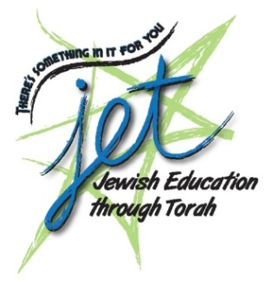 | JET WINTER SHABBATON  REGISTRATION FORM  January 23 - 25, 2015  Best Western Plus Victoria Park Suites Hotel  377 O’Connor St. (at Gladstone)

Names of Adults Attending:
Names of Children Attending: |  |  |  |  |  |  | Ages:
Address:
City: |  |  |  | Postal Code:
Telephone: |  |  | E-Mail:

Please note: All rates based on a minimum of adult double occupancy and check-out Sunday morning
Adults: |  | # of Adults |  | @ $250.00 each (before January 16th)  @ $260.00 each (after January 16th) =
Children: | # Under 2 |  |  | FREE |  |  | FREE
 | # Ages 2 – 11 |  |  | @ $60.00 each |  | =
 | # Ages 12 – 15 |  |  | @ $90.00 each |  | =
 |  |  |  |  | TOTAL ENCLOSED =

Method of Payment (check one): |  |  |  | Cheque |  | Cash |  | Visa |  | MasterCard
Name:
Card Number: |  |  |  |  |  |  |  | Expiration Date:
If you have any special needs, including dietary requirements or limitations,
please advise the JET office: 613.695.4800 or info@jetottawa.com
Please return this form with your payment in one of the following ways:
Mail to JET, 21 Nadolny Sachs Private, Ottawa, ON K2A 1R9
Email us at info@jetottawa.com

